In your own words list what each hardware component does and also insert a picture of it

1. CPU - brains of computer, executes sequences

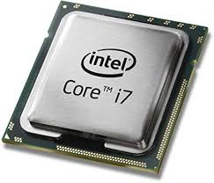

1. RAM – temporarily stored data

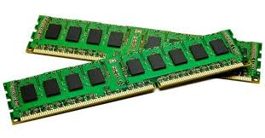

1. HDD – locally stores data

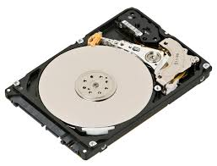

1. Motherboard – allows all other components to work together

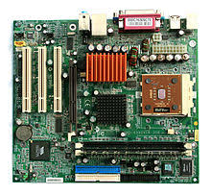

1. Network interface card – enables access to a wired or wireless internet connection

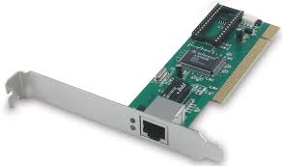

1. Switch – connects devices together on a network via packet switching

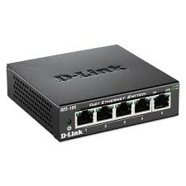

1. Router – connect multiple networks and forwards packets

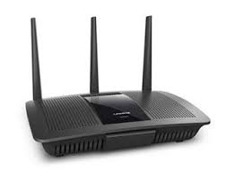

1. Server – servers data to clients on a network

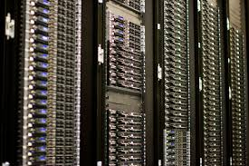

What are the 3 families of Intel I series CPUs? Which one is recommended one today for a laptop?

i3, i5, i7; an i5 is recommended for laptops today

What are the primary differences between the 3 types of CPUs?

Each member has more cores and better speeds than the last.

Why would you use an i5 when you can afford to get an i7?

I5 will consume is less power and is capable of doing everything an i7 can do

What is the difference between HDD and SSD?

HDD is mechanically reads data, while SDDsaves data on microchips

What is the recommended amount of RAM in a system today?

8 GB Ram

How fast (Ghz) should your standard CPU be running today?

2.3 GHz and up

What is the purpose of using networks?

Provide access to shared sources

What is a bit and how many bits make a Byte?

A unit of data in computers, 8 bits 1 byte

What is the difference between IP address and MAC address?

IP addresses are assigned to every computer, MAC addresses stay locally

What are the newest and fastest type of SSD available today?

Samsung 850 evo

Which OS is most popular today and why?

Windows, for its reliability and user friendly interface

List the benefits and disadvantages of using Wifi.

Wifi is more convenient but easier for people to infiltrate your computer

What are 4 basic functions of a computer?

Input, output, graphics, internet